Lecture No.9 PARASITOLOGY DR.Raad H.H.
Order Srongylida
Family Ancylostomidae
Characterized by :
- Hook worm habitats small intestine of mammals.
- Small size nematode .
- Adults are cylindrical grayish yellow tapering interiorly and slightly curved ,with head bent back dorsally forming a HOOK
- The buccal cavity large highly cuticularized provided with teeth or cutting plates which they used for attachment.
- L3 infects host through skin penetration.

Genus Bunostomum
Most important spp. Bunostomum trigonocephalum (Male 14 mm
Female 24 mm) and B. phlebotomum.
- habitats small intestine of ruminants.
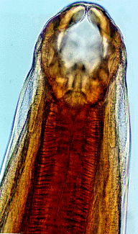
- Pair of cutting plates at the anterior edge of the buccal capsule are used to abrade the mucosa during feeding.
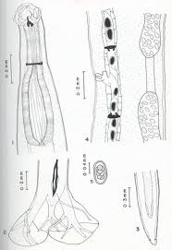
Fig. Bunostomum trigonocephalum cutting plates seen on the ventral aspect of the mouth.
- Direct life cycle L1→L2 →L3 (molt in environment; L3 infects host through penetration of skin or mouth mucosa) → blood and lymphatic vessels →lungs –molt to L4→ swallowing →small intestine .
- Adult maturation until lay eggs about 2 months (The prepatent period).
- Bunostomum phlebotomum Infects Man ,often causing CREEPING DERMATITIS or CREEPING ERUPTION
- Symptoms :
Larval penetration of the lower limbs may cause uneasiness and stamping, particularly in stabled cattle. Adult worms cause anemia and rapid weight loss. Diarrhea and constipation may alternate. Hypoproteinemic edema may be present, but bottle jaw is rarely as severe as in haemonchosis. During the patent period, a diagnosis may be made by demonstrating the characteristic eggs in the feces.
- Diagnosis:
- Flotation fecal test & EPG counts for eggs
- Fecal culture for larvae.
- P.M.
On necropsy, the mucosa may appear congested and swollen, with numerous small hemorrhagic points where the worms were attached. The worms are readily seen in the first few feet of the small intestine, and the contents are often blood-stained. As few as 2,000 worms may cause death in calves. Local lesions, edema, and scab formation may result from penetration of larvae into the skin of resistant calves.
- General G.I.T. Parasites of Ruminants Control & Prevention :
Effective worm control cannot always be achieved by drugs alone; however, anthelmintics play an important role they may be used to reduce pasture contamination, particularly at times when seeding of the pasture with parasite eggs is a prerequisite for the development of an infective challenge necessary to cause clinical parasitism. Coordination with other methods of control, such as alternate grazing of different host species, integrated rotational grazing of different age groups within a single host species (including creep grazing), and alternation of grazing and cropping, are other management techniques that can provide safe pasture and give economic advantage when combined with anthelmintic treatment.

Genus Ancylostoma
Identification :
Canine hookworm one of the most common intestinal parasites of dogs and cats (especially puppies and kittens). It can cause severe disease including anemia and serious diarrhea.
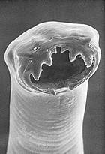
Ancylostoma caninum
- With deep capsule (bent dorsally) and 3 pairs of teeth .

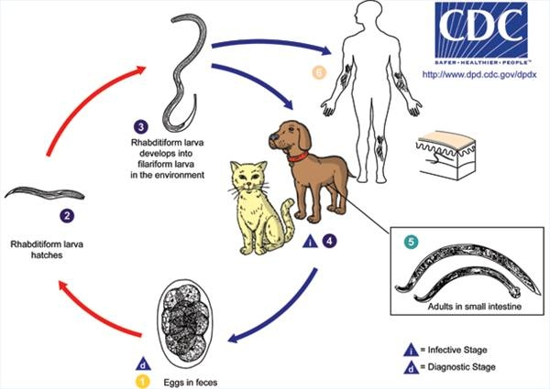

- A. caninum Dog, fox (intestine), possibly humans with females measuring 15-18 mm and males 9-12 mm. and requires a warmer climate to develop.
- Routs of L3 infective stage :
- eating infective larvae
- skin penetration
- colostral or lactogenic ingestion to puppies
- prenatal infection
- infects man ,often causing creeping dermatitis or creeping eruption.
- Diagnosis is based on clinical signs and finding large numbers of hookworm eggs (several thousand eggs per gram) in fresh stool samples. Anemia may develop before the eggs can be demonstrated to be in the feces, therefore, your veterinarian may have to examine three consecutive fecal samples taken two to three days apart to confirm the diagnosis; Infections usually occur during warm, damp days. These conditions allow for the rapid development and prolonged survival of infective larvae in the soil.
- Treatment program ,Several anthelmintics are available.
- Remove feces regularly from runs, kennels and any place where dogs are confined. Larval hookworms do not survive desiccation, so keep the ground and pens dry.

Ancylostoma duodenale
deep capsule (bent dorsally) and 2 pairs of teeth; infects human. "Old World hookworm"
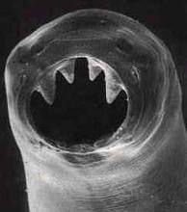

- Life cycle , pathogenesis , symotoms , diagnosis , prevention as in A. caninum.
Genus Uncinaria
Identification :
- U. stenocephala canine hookworm small intestine of Dog, cat, fox
- The smaller species, Uncinaria stenocephala (males = 7.0 mm; females = 10.0 mm long) ;buccal cavity with 2 pairs of cutting plates; tolerates the temperate &cold climates.
- Infects Man ,often causing creeping dermatitis or creeping eruption
- Other aspects as in A. caninum
Genus Necator
Necator americanus
Identification:
- New World human hookworm
- The anterior end of N. americanus is armed with a 2 pairs of curved cutting plates.
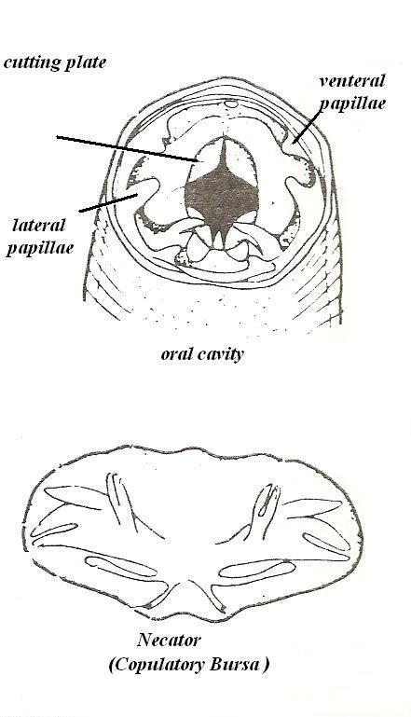
- It is a parasitic nematode worm that lives in the small intestine of hosts such as humans, dogs and cats.

- Can cause severe disease including anemia and serious diarrhea.
- Infects Man ,often causing creeping dermatitis or creeping eruption.
- Other aspects as in A. caninum

Hookworm Zoonotic significance
- Cutaneous larva migrans in man particularly children , also known as creeping eruption“, is a dermatitis caused by migrating hookworm larvae that not reach mature stage . Infection occurs through skin contact with infective larvae and the most common sources of infection are shaded moist sandy areas or soil that has become contaminated via the feces of infected dogs or cats.
- Sometimes referred to as "creeping eruption" or "ground itch", in some parts of the Southern USA this condition is also referred to as "sandworms," as the larvae like to live in sandy soil
- The general clinical symptoms in humans are erythema at the sites of infection and intensive pruritus. The severity, and also persistence, of the skin lesions are related to the immune status of the individual person. Hypersensitivity related to previous infection has been reported. Although a few cases of adult dog hookworms in the intestines of man have been reported, the risk of such infections does not appear widespread.
- Systemic signs include peripheral eosinophilia (Loeffler syndrome), migratory pulmonary infiltrates, and increased immunoglobulin E (IgE) levels, but are rarely seen.
- Pathological Cutaneous Signs of cutaneous larva migrans (CLM) include the following:
  - Pruritic, erythematous, edematous papules ; vesicles.
  - Serpiginous (snakelike), slightly elevated, erythematous tunnels that are 2- to 3-mm wide and track 3-4 cm from the penetration site .
  - Nonspecific dermatitis
  - Vesicles with serous fluid
  - Secondary impetiginization.
  - Tract advancement of 1-2 cm/d.

Family Trichostrongylidae
- worm habitates the fourth stomach (abomasums) &small intestine of ruminants &other mammles ; avain and human.
- Thin Small size nematode0.5-3cm .
- Coulatory bursa large specially lateral lobes plus small dorsal lobe.
- The buccal cavity small or rudimentary or nonexistent , without teeth or cutting plates.
- Egg divided embryo 8-32 cells.
- L3 infects host through ingestion.
Genus Trichostrongylus
Characters:
- Most species in this genus have been described from ruminants abomasums and duodenum in primitive rodents around the world. Species have also been found in birds, human and non-human primates, camel, pigs and equines.
- The genus was first described by Looss in 1905. Over thirty species.
- These are small worms (less than 1 cm long), rudimentary buccal cavity. The bursa of the male has large lateral lobes with a relatively short dorsal lobe and additional piece called Gubernaculm. The vulva of the female is located slightly posterior to mid body covered by Flap. The uterus is filled with eggs that are thin shelled and of the typical strongylid type.
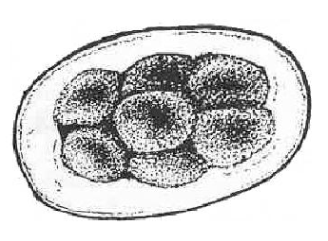

- known commonly as the stomach hairworm

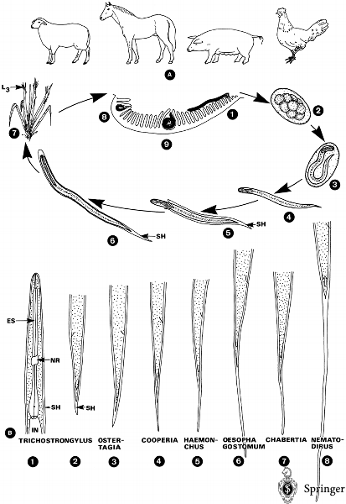
Fig. :Trichostrongylidae·. A Life cycle of trichostrongylid of different hosts. 1. Adults (see ) live attached to the villi of abomasum or small intestine (species-specific) and feed on blood (e.g., Haemonchus). 2. Smooth-walled eggs are passed unembryonated in host's feces. 3. Larvae are developed under favorable conditions inside the eggs. 4–7 Except for , the L₁ hatches from the egg and feeds on detritus. After two molts the L₃ stage is achieved, which is infective to final hosts. The third-stage larvae, still wearing the loosely fitting second-stage (= sheath), climb to the top of plants (7) and may even hibernate outside a host. 8–9 If final hosts swallow the L₃ with forage, the exsheathment takes place in the stomach. The larvae of some species may burrow into the mucosa and there twice; larvae of other species molt when attached to the villi. In some species (e.g., the fourth-stage larvae may hibernate inside the mucosa for 3–5 months; this phenomenon is described as "Spring Rise" ; In spring these L₄ complete their development and become mature after another molt. The increased excretion of eggs is known as B The anterior (1) and posterior (2–8) regions of infective larvae (L₃) of different genera parasitizing sheep, according to several authors. ES, esophagus; L₃, third-stage larva; NR, nerve ring; SH, sheath (cuticle of the preceding larval stage).
- Can cause mild intestinal disturbances and chronic catarrhal gastritis ;when present in large numbers, Lesions within the gastric mucosa can cause haemorrhage, with loss of plasma proteins and reduced absorption of nutrients.
- Spices Trichostrongylus axei , T.colobriformis .

Genus Haemonchus
Characters:
- Species in this genus infects ruminants (sheep & cattle ) abomasums and Species have also been found in camel.
- The genus species called Blood Suckers ;Red In Color. .
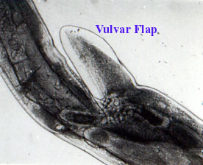
- These are small worms (less than 3 cm long) small a buccal cavity with one small tooth at the base.. The copultory bursa of the male has large lateral lobes with a relatively short dorsal lobe like Y letter shape. The vulva of the female is located slightly posterior to midbody covered by Flap. The uterus is filled with eggs that are thin shelled and of the typical strongylid type.

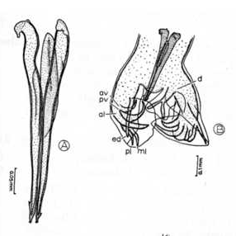
e.g. Haemonchus contortus In this worm the vulva is protected by a flap of the cuticle.

A. Haemonchus contortus spicules.
B. Haemonchus contortus male bursa.

Haemonchus contortus,
- also known as red stomach worm, wire worm or Barber's pole worm, is very common parasite and one the most pathogenic nematode of ruminants. Adult worms are attached to abomasal mucosa and feed on the blood. This parasite is responsible for anemia, bottle jaw, and death of infected sheep and goats, mainly during summer months in warm, humid climates.
- Females may lay over 5,000 eggs a day, which are secreted from the animal via the faeces. After hatching from their eggs, H. contortus larvae molt several times, resulting in an L3 form that is infectious for the animals. They can take up these larvae when eating grass leaves. The L4 larvae, formed after another molt, suck blood in the abomasum of the animal, potentially giving rise to anaemia and oedema, which eventually can lead to death.
- The adult female is 18–30 mm long and is easily recognized by its trademark “barber pole” coloration. The red and white appearance is due to the fact the Haemonchus contortus is a blood feeder and is due to the white ovaries that coil around the intestines which are filled with blood. The male adult worm is much smaller at 10–20 mm long and displays the distinct feature of a well developed copulatory bursa, containing an asymmetrical dorsal lobe and a Y shaped dorsal ray.
- It is the most important ruminant helminthes specially young ages
- Pathogenicity :The nematode piercing the abomasum causes a number of significant complications in the infected ruminants that can lead to death. The infected animals can display severe dehydration, diarrhea, unthrifty appearance, lethargy, depressed low energy behavior, rough hair coat and uncoordinated movements. Furthermore, significantly reduced growth and poor reproductive performance has been observed. The accumulation of fluid in the abdomen, gut wall, thoracic cavity and submandibular tissue – a phenomenon commonly called "bottle jaw”, also is a common association with this infection. Severe blood loss, white mucous membranes, and anemia/PCV are common complications of the infection.
- Haemonchus placei ; Barberpole worm Cattle.
- General G.I.T. Parasites of Ruminants control & prevention as described in Bonustomum

Genus Ostertagia:
- Members of this genus Ostertagia ostertagi in habitats Cattle abomasums, sheep and goats occasionally; O. circumcincta , O. trifurcate sheep and goats abomasums.
- known commonly as the brown stomach worm.
- Ostertagia is the most important endoparasite of cattle worldwide. Damage to the abdomen can result in lost productivity throughout the life of the animal. Eggs Once hatched, larvae undergo two moults to become infective larvae L3 stage, which migrate onto herbage and are ingested by grazing cattle. In the abomasums the L3 larvae lose their protective sheaths. They then burrow into the glands of the wall of the abomasum. After moulting to become early L4 , larvae (L4) development may continue without delay or be interrupted by a period of up to several months. The lining of the abomasum is significantly damaged when the larvae emerge as immature adult worms turned to fibrous tissues forming Nodules .
Type I ostertagiasis form occurs in calves during their first grazing season as a result of maturation of ingested larvae in the abomasum. causes profuse greensh watery diarrhoea in calves at grass.
Type II ostertagiasis results when these inhibited larvae resume their development, usually from February to May, the emerging larvae causing the same lesions as those causing type I disease.
- Although adult cattle acquire immunity by the age of 18 months, occasionally bulls grazing calf paddocks or cows suffering from immunosuppression due to other diseases , such as fascioliasis, may suffer from type II ostertagiasis.
- Diagnostic Information: Strongyle-type eggs appear in the faeces; third-stage larvae cultured from them may be identified as Ostertagia.

Genus cooperia
- Members of this genus infects small intestine of ruminants rarly abomasums.
- No Gebrnaculum with notched end , generally resemble Trichostrongylus .
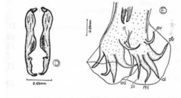
- Several species of Cooperia occur in the small intestine of cattle; C .punctata , C .oncophora , and C. pectinata are the most common. The red, coiled adults are 5-8 mm long, and the male has a large bursa. They may be difficult to observe grossly. Their life cycle is essentially the same as that of other trichostrongylids. These worms apparently do not suck blood. Most of them are found in the first 10-20 ft (3-6 m) of the small intestine. The prepatent period is 12-15 days.

- In heavy infections with C punctata and C pectinata , there is profuse diarrhea, anorexia, and emaciation, but no anemia; the upper small intestine shows marked congestion of the mucosa with small hemorrhages. The mucosa may show a fine lace-like superficial necrosis.
Genus Nematodirus
- Members of this genus infects small intestine of ruminants & camels.
- Thin worms with rediumantry buccal cavity ; male with two long spicules.
- Nematodirus battus a parasite of sheep; causes nematodiriasis eggs very resistant to cold and freezing.
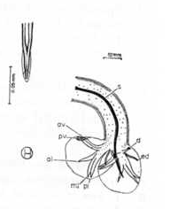
- Nematodirus is generally a spring infection of lambs. Sever enteritis Outbreaks of the disease are most common in May and June.

Genus Camelo strongylus
genus Includes Camelo strongylus mentulatus (sheep, camel, wild ruminants).it is called Ostertagia of camels ;infects camels abomasums; disease resemble Ostertagia in general.

Family Dictyocaulidae
Characterized by:
- parasites of respiratory system of ungulates
- caudal bursa round

genus Dictyocaulus
identification:
- worms habitas in bronchial tree system of lung ;called Lung worms
- In ungulates D. viviparus is the most common lungworm of cattle& deer ; D.Filaria most common lungworm of sheep and goat , deer camel & In equine Dictyocaulus arnfeldii is the lungworm of horses
- Associated with bronchitits in sheep & cattel and called Husk or verminous bronchitis and pneumonia.
- Eggs thin shelled with L1
- Whitish nematode thin filamentous thread like 5-10 cm. founded as groups or masses in the air passages like a NET and from this the name came .
- Small buccal cavity with 4 lips .
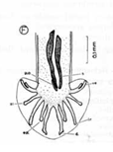
- Male dorsal two rays fusion point site in the cpoulatory bursa it is a matter of interest of classification as follow:
- Complete fusion as in D.viviparous
- Fused in the middle as in D.arnfieldi
- Fused at the summit as in D.filaria

- Dictyocaulus has a direct life cycle, Cattle grazing then ingest the L3 larvae. These larvae go through the intestinal system and penetrate the intestinal wall. They use the lymphatic system to reach the mesenteric lymph nodes, where they mature once again into L4 stage larvae. The L4 larvae use the blood supply and the lymphatic system to reach the lungs, molt to L5 where they become adults and begins to lay eggs which larvated in 1 month to L1 post infection ,the life cyle is completed.
- Clinical Signs
- In mild infections the disease may be asymptomatic
- In heavy infections: During the first 25 days of infection there may be nasal discharge , tachypnea and coughing. During days 25 to 55 the lung signs increase in intensity with harsh lung sounds (bronchi and emphysematous crackling) being heard. In severe infections, complications may result in the death of 20 % or more of the infected animals.
- Young ages more susceptible than older ages which considered as carrier .
- Diagnosis:
- using a Baerman apparatus & Fecal flotation (zinc sulfate centrifugation) , rarely found eggs but mostly L1 present identified by 0.5 mm. with cuticular knob in the anterior end in addition to brownish food granules in posterior mid half and bluntly pointed tail for eggs identification of thin shell 70-100 u.
- Microscope detection of eggs or larvae in the coughed up sputum or broncho alveolar lavage fluid from affected animal
- Blood serology test for worm antigens
- P.M. of bronchial tree for adults & larvae .
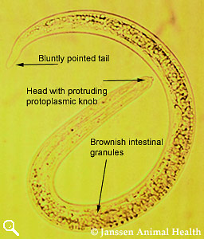

- Prevention and control of lung worm :
- Avoid breeding of young ages with dames.
- Give a full course of vaccination prior to first season (with second dose at least two weeks before worming). In areas of high lungworm risk give single booster dose prior to turnout in second season.
- Treating Herds using long-acting/continuous release anthelmintics (including fenbendazole slow release boluses) which give cover throughout the ENTIRE first grazing season.
- Preventive anthelmintics -Dewormer prior and in grazing season .
- Dictyocaulus and Protostrongylus can be treated effectively with levamisole (8 mg/kg, SC or PO), ivermectin (0.2 mg/kg, SC or PO), fenbendazole (5-10 mg/kg, PO), moxidectin (0.2 mg/kg, PO or SC), or febantel (5 mg/kg, PO). Ivermectin (0.3 mg/kg, SC or PO), fenbendazole (15 mg/kg, PO, administered twice, 3 wk apart), and albendazole (10 mg/kg, PO) have been reported to be effective in treatment of Muellerius .

Genus Muellerius ellerius
identification:
- Muellerius capillaris
Muellerius have indirect life cycles and rely on a variety of snails and slugs to serve as intermediate hosts.
- Male without copulatory bursa , posterior spirally coiled end provided with sensory papillae around cloaca .

Mue 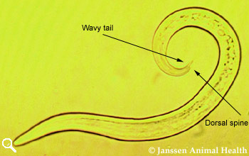llerius

- Adult Muellerius live in alveoli and lung parenchymal tissue and are considered the least pathogenic of the 3 lungworms. Muellerius appears to cause more problems for goats than for sheep.
- also known as hair lungworm, is nematode parasite of small ruminants. Adult worms occur in small air passages (bronchioles, bronchioli) and in the alveoli, even in the subpleural tissue. In ruminants, parasite causes chronic bronchopneumonia. In case of massive infection or secondary bacterial infection, M. capillaris infection can cause death of the host.
There are two other genera in this family named as Protostrongylus (indirect life cycle ; have indirect life cycles and rely on a variety of snails and slugs to serve as intermediate hosts; species Protostrongylus rufescens found in sheep, goats and deer; cause of chronic bronchopneumonia ) ; and genus Cystocaulus .

Family Metastrongylidae
Genus Metastrongylus :
Members are infects bronchial system of pigs , rarely sheep and cattle ; indirect life cycles and rely on a variety of earthworm to serve as intermediate hosts; clinically as in Protostrongylus.

